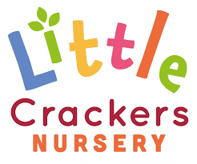 26th June 2020
Weekly News

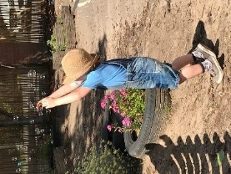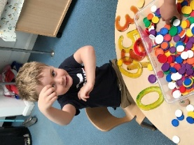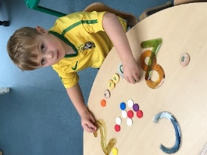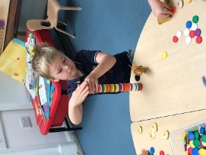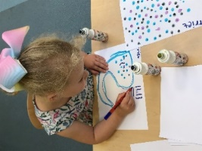

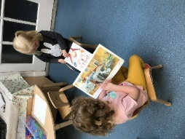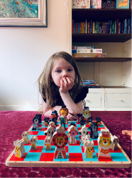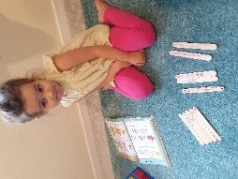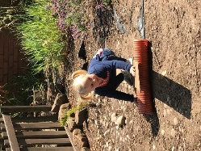

Thank you, Cameron…  for this week’s joke!  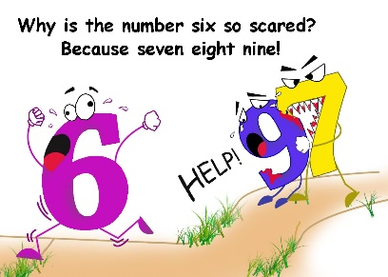  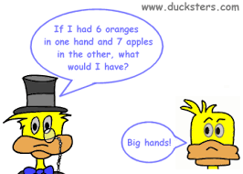  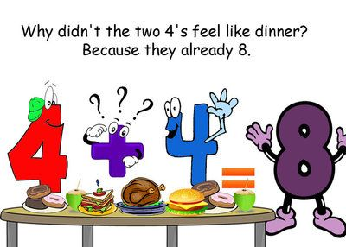 | Basic cooking skills for under-fives  Being able to cook is a great skill to have, and whilst it can sometimes feel like a chore to us, it’s an exciting activity for our little ones. It’s also a terrific way to get children interested in food in general, or to help them with food issues; to feel comfortable with ingredients they don’t currently eat. You can start with the following basic cooking skills:  ● Buttering a slice of bread.  ● Cracking eggs by tapping the centre of the egg over the rim of a small bowl, and then using thumbs to pull the two halves apart.  ● Decorating fairy cakes or biscuits – spreading on the icing butter or just adding the sprinkles or other toppings.  ● Kneading and rolling out dough using a rolling pin.  ● Cutting shapes out using cookie cutters.  ● Using a sieve – by holding over a larger bowl and gently shaking.  ● Cutting soft fruit or vegetables, for example, a banana, with a non-sharp knife.  ● Grating cheese – especially good if you’ve got a rotary grater.  ● Crushing biscuits for bases or non-cook chocolate recipes – in a plastic bag with a rolling pin.  ● Rubbing in butter and flour for crumble.  ● Crushing garlic in a garlic press.  ● Greasing and lining cake tins.  ● Mashing bananas with the back of a fork for banana bread/cake.  ● Mashing potato with a potato masher.  ● Peeling vegetables with a vegetable peeler. | Why not try…  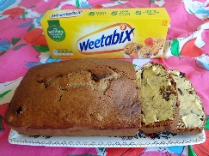  Weetabix Cake  A great recipe for children to help with – they love crushing the Weetabix!  Ingredients  ● 300g self-raising flour  ● 25g sugar  ● 200g raisins (or any other dried fruit)  ● 2 Weetabix (crushed)  ● 1/2 –1 tsp mixed spice  ● 275ml milk  ● 1 medium egg (beaten)  Method  Measure out all the dried ingredients into a large bowl. Pour in the milk and egg, and mix well (the mixture will look like a lumpy batter). Pour the mixture into a greased and lined loaf tin. Bake at 130°C/Gas 3 for around 1 hr 15 mins, until it is firm to touch, golden brown and a skewer or knife comes out clean. Cut into slices when cool.

Little Crackers Nursery · Crackley Hall · St Joseph’s Park · Kenilworth · CV8 2FT
Telephone: 01926 514444 · Fax: 01926 514455 · e-mail: littlecrackers@crackleyhall.co.uk
www.crackleyhall.co.uk

Registered Charity Number 1087124 Company limited by guarantee Number 4177718

